Incharge Pricipal Of PU college:

V R Manjula

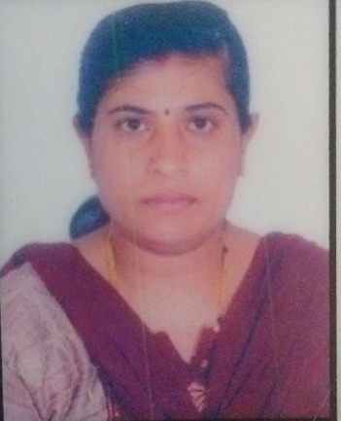

Edu - M.A,M.Phil

Teaching experience – 17 years

Joining date – 05/11/2007

Principal Of High school:

Kantaruju B G  
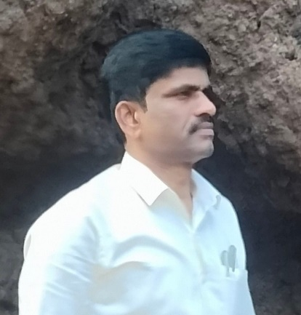

Edu – MSc, M.Ed, KES

Teaching experience – 17 years

Joining date – 15/06/2007

Incharge Pricipal Of Primary School:  
SREENIVASA G

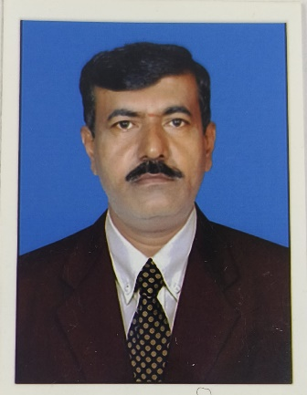  
Edu – CPEd, Kan& Eng Sr typing, PUC  
Teaching experience – 29 years

Joining date – 26/07/1994